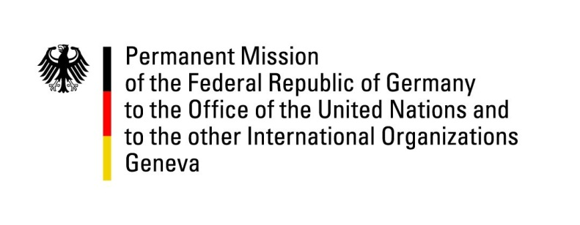

40th Session of the United Nations Human Rights Council

Geneva, 14 March 2019

HRC40

UPR Outcomes China

German Statement

Mr. President,
Germany welcomes the fact that China has accepted many recommendations made by other countries. We encourage China to implement these recommendations in a timely manner and to share information on the implementation.
At the same time, Germany notes with disappointment China’s reaction to our UPR recommendations.
We recommended to end all unlawful detention including unconstitutional mass detention of Uyghurs and other Muslims in Xinjiang, and “residential surveillance at a designated location”. China did not accept this recommendation and argued that human rights in Xinjiang were “seriously protected”. Since a multitude of reports show a different picture, it would have been expedient had China accepted another one of our recommendations, namely to allow independent observers – including Special Procedures – unhindered access to all regions. Unfortunately, China did not accept this recommendation either, calling such proposition interference in China’s internal affairs. But the system of Special Procedures is a central element of the United Nations human rights framework, with which China committed to cooperate in good faith. We, therefore, feel that it would be consistent with China’s commitment to allow access to Special Procedures, and renew our call on China to reconsider its stance.
China did accept our recommendations to respect the rights to freedom of religion and belief, opinion and expression, peaceful assembly and culture and to guarantee fair trials and allow all defendants unhindered access to chosen lawyers. China stated also that these recommendations were already implemented. However, we still see ample room for improvement in these areas and call on China to ensure that international standards of human rights in these fields are fully met.

Thank you.

