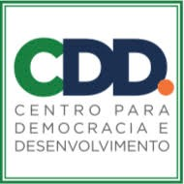

BRIEFING PAPER
Universal Periodic Review

OCTOBER 2020

THE SITUATION OF HUMAN RIGHTS DEFENDERS IN
MOZAMBIQUE

Contacts

Adelaïde ETONG KAME  International Service for Human Rights  a.etong@ishr.ch | Prof. Adriano Nuvunga  Centro para Democracia E Desenvolvimento  adriano.nuvunga@cddmoz.org

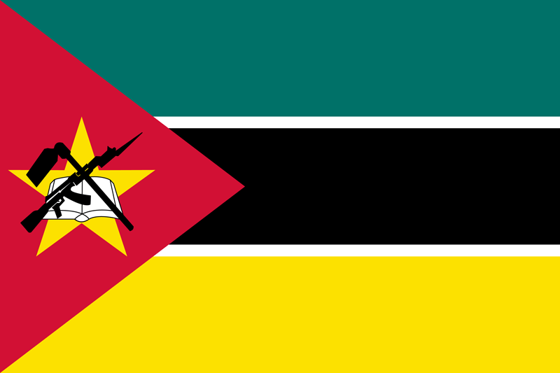
During its last UPR in 2016, Mozambique accepted 180 recommendations. The government only noted all recommendations referring specifically to human rights defenders and accepted 10 recommendations on freedom of expression, freedom of association, the right to peaceful assembly, and the operationalisation of its national human rights institution in line with the Paris Principles. These recommendations called on the State to revisit the legal framework governing the civil society sector, protect the rights of freedom of expression and peaceful demonstrations and ensure that the National Human Rights Commission has sufficient resources, personnel and a clear mandate to carry out its work in line with the Paris Principles. However, since its last review there is a persistent harassment of civil society and human rights defenders more specifically.

- RISKS FACING HUMAN RIGHTS DEFENDERS
- Despite the right to freedom of association being constitutionally guaranteed under article 52, the government frequently prohibits protests alleging errors in applications for authorisation by the organisers. Moreover, in an attempt to silence civil society and media voices, defenders are frequently harassed, intimidated or subjected to defamation campaigns, arbitrary arrest and death threats for openly criticising the governance of the country.
- The beginning of 2020 was marred by terrorist attacks in the northern and central districts of Cabo Delgado. 17 national and international organisations wrote to the President of the Republic of Mozambique to express their concerns about violence committed by members of the Rapid Intervention Unit (RIU) and the Special Operation Group and denounce harassment and intimidation against defenders.
- Journalists are equally silenced, harassed, intimidated, arrested and detained. Indeed, Amade Abubacar and Germano Adriano, journalists, were arrested in January 2020 and charged with “spreading messages damaging to the Mozambican Armed Forces” for reporting on the current political and social conditions in Cabo Delgado. Amade was arrested without a warrant and held for almost 100 days. He is still awaiting trial. Furthermore, the governor of Cabo Delgado openly threatened journalists while at a press conference in Pemba threatening them to stop reporting on the abuses or face the consequences as there was much more happening in the province than human rights abuses.
- In August 2020, Amnesty International called out on President Nyusi and other government affiliates for subjecting Bishop Don Luis Fernando Lisboa of Pemba city to a smear campaign undermining and delegitimizing his vital human rights work in the province of Cabo Delgado.
- Ahead of the general elections held in October 2019, human rights defenders perceived as critical of the government reported being intimidated. In addition, organisations who monitored the elections reported major obstruction to their work, harassment and having received death threats. The same month, Dr. Anastacio Matavel, election observer, was shot and killed as he left an election training session .
- On 5 February, following the announcement of the Administrative Court’s decision not to allow Manuel de Araujo to run for a second term as the mayor of Quelimane city, demonstrators went to the streets. Police used excessive force and arrested at least 15 protesters as well as journalist, Nhama Matabicho, who was then beaten and his equipment confiscated.
- Canal de Moçambique is an independent weekly newspaper known for pursuing and investigating cases of injustice and political life. It is often qualified as the opposition newspaper. On 23 August 2020, the newspaper was attacked by an unidentified group. The group broke into Canal’s offices and set it on fire which made it the first ever attack of this nature on a media house.
- Since 3 October 2020, Adriano Nuvunga, Executive Director of the Centre for Democracy and Development (CDD) has been receiving anonymous calls threatening to bomb his home saying that a bomb had been planted in his house and could explode at any moment. Since then, he has evacuated the house with his family.
- OFFICIAL RESTRICTIONS ON THE SPACE FOR HUMAN RIGHTS DEFENDERS
- The legal context in which NGOs work in Mozambique is one of the most restrictive in Southern Africa.
- Law 7/2001 of 7 July contains an obligation for an organisation wishing to assemble to notify the government in advance. In addition, they also face time limits as to when they can assemble during the day, not allowing them to enjoy this freedom at all times.
- The same law (Law on Association) which regulates the registration and operation of associations includes several provisions making it excessively difficult for civil society to work effectively. In order to be legally recognised, an association must have ten founding members and produce an excessive number of documents. Moreover, it includes a provision specifying that the objectives of the association must not “offend public morals” which is often used to deny registration to LGBTI associations such as the Mozambican Association for the Defense of Sexual Minorities (LAMBDA).
- HUMAN RIGHTS DEFENDERS FACING PARTICULAR RISKS
- Defenders working on environmental issues, corporate accountability for human rights violations or to promote better standards of living for rural communities especially through access to water and ensuring fair compensation for their lands are under heightened risks and subjected to various forms of harassment, intimidation and threats.
- In July 2018, when defenders protested against the forced relocation of local resident in Inhassunge District by a mining company, they were met with disproportionate use of violence by the authorities costing the life of one person and two others were injured.
- Even though homosexuality was decriminalised in 2015, LGBTI+ people continue to face significant discrimination. Moreover, in Mozambique, being a LGBTI+ defenders or an organisation promoting the rights of LGBTI+ persons often leads to difficulties in obtaining legal recognition and registration, which impedes on their ability to conduct their activities. For example, the Mozambican Association for the Defense of Sexual Minorities (LAMBDA) has been waiting for the approval for its registration since it first applied for it in 2008.
- The Centre for Public Integrity (CIP) and its collaborators are constant targets of various threats from the public authority regarding the work they do against corruption.
- Since January 2019, woman human rights defender Fátima Mimbire, working for the Centre for Public Integrity’s (CIP), has been the victim of a smear campaign and intimidation through social media in an attempt to further delegitimize her work. This happened when she took up an active role in asking the Mozambique government to repay loans it acquired illegally and secretly.
- THE RESPONSE OF THE STATE REGARDING THE PROTECTION OF HUMAN RIGHTS DEFENDERS
- Hate speech against dissidents and human rights defenders is institutionalised and mainly carried out by figures close to the President of the Republic who hold important functions in the Public Administration of the country. They often advise and encourage the Government to resort to the use of “extra-legal” means to silence journalists and activists.
- In 2016, the Mozambican Bar Association seized the Administrative Court of the City of Maputo, demanding that it recognises the right to freedom of association of the organisation LAMBDA and finally approve its legal registration. To date the court has not yet decided. In 2017, Mozambique's Constitutional Council struck as unconstitutional the provision included in article 10 of the Law of Association which has been used to deny registration to LAMBDA. However, in spite of the decision of the Constitutional Council, the Administrative Court is yet to deliver its decision and LAMBDA is still not a registered organisation.
- In 2018 two communications were sent to Mozambique by UN Special Procedures regarding the adoption of Decree 40/2018 imposing exorbitant fees on local and foreign media operating in the country and the threats, abduction and beating of Mr. Ericino de Salema, journalist, human rights lawyer and human rights defender in Mozambique. However, no response was received to these communications. The Special Procedures highlighted their concerns about the negative effect that the Decree will have on media outlet finances, restricting their abilities to do their work and urged the government to halt the alleged abuse against Mr Ericino de Salema.

RECOMMENDATIONS TO THE GOVERNMENT OF MOZAMBIQUE:
- Adopt and implement the changes to the 1991 Law of Association suggested by UNDP since 2008 to ensure that the law no longer restricts the rights and activities of civil society associations and allow for any association to legally register, including LAMBDA;
- Develop and enact specific laws and policies to recognise and protect the work of human rights defenders and which give full force and effect to the UN Declaration on Human Rights Defenders at the national level.
- Combat impunity by ensuring the prompt, thorough and impartial investigation of all violations against HRDs, the prosecution of perpetrators, and access to effective remedies for victims;
- Refrain from criminalising the legitimate activities of HRDs and hold accountable those who promote hate speech against defenders;
- Provide a safe and enabling environment for meaningful civil society participation in the development and implementation of public policies, in particular that guarantee the free, prior and informed consultation of communities affected by economic and development projects;
- Cooperate fully with the Special Procedures of the UN Human Rights Council, including by providing timely and substantive response to all communications;

ABOUT THIS BRIEFING PAPER
ISHR and Centro para Democracia E Desenvolvimento encourage States to consult UPR submissions by local activists and make recommendations to Mozambique regarding the protection of HRDs. This paper is a result of compiling public information and direct contact and experience in the protection of HRDs. Readers should consult sources provided for additional information.

https://www.constituteproject.org/constitution/Mozambique_2007?lang=en
https://freedomhouse.org/country/mozambique/freedom-world/2020
https://www.civicus.org/index.php/fr/medias-ressources/122-news/interviews/2661-mozambique-ngos-battle-for-free-civic-space
https://cddmoz.org/wp-content/uploads/2020/09/REPORT-ON-HUMAN-RIGHTS-AND-HUMAN-RIGHTS-DEFENDERS-FOR-THE-FIRST-HALF-OF-2020-IN-MOZAMBIQUE.pdf
https://rsf.org/en/news/two-mozambican-journalists-freed-after-being-held-months
https://www.amnesty.org/en/countries/africa/mozambique/report-mozambique/
https://www.amnesty.org/en/documents/afr41/2914/2020/en/
https://globalvoices.org/2019/10/23/mozambican-journalists-and-activists-targeted-with-threats-in-election-year/
https://www.hrw.org/world-report/2020/country-chapters/mozambique
https://www.omct.org/human-rights-defenders/urgent-interventions/mozambique/2019/10/d25545/
https://www.amnesty.org/en/countries/africa/mozambique/report-mozambique/
https://www.amnesty.org/en/documents/afr41/2947/2020/en/
https://www.amnesty.org/download/Documents/AFR4129472020ENGLISH.pdf
https://www.amnesty.org/en/latest/news/2020/10/mozambique-investigate-bomb-threats-against-civil-society-leader/
https://freedomhouse.org/country/mozambique/freedom-world/2020
https://www.caicc.org.mz/cd/leis/Files/Direito%20de%20Associacao/Lei%20das%20Associacoes.pdf
https://www.civicus.org/index.php/fr/medias-ressources/122-news/interviews/2661-mozambique-ngos-battle-for-free-civic-space
https://www.frontlinedefenders.org/en/location/mozambique
https://freedomhouse.org/country/mozambique/freedom-world/2020
https://cddmoz.org/wp-content/uploads/2020/09/REPORT-ON-HUMAN-RIGHTS-AND-HUMAN-RIGHTS-DEFENDERS-FOR-THE-FIRST-HALF-OF-2020-IN-MOZAMBIQUE.pdf
https://www.amnesty.org/en/documents/afr41/9744/2019/en/
https://cddmoz.org/wp-content/uploads/2020/09/REPORT-ON-HUMAN-RIGHTS-AND-HUMAN-RIGHTS-DEFENDERS-FOR-THE-FIRST-HALF-OF-2020-IN-MOZAMBIQUE.pdf, p.21
https://allafrica.com/stories/201711130442.html
https://spcommreports.ohchr.org/TMResultsBase/DownLoadPublicCommunicationFile?gId=24056
https://spcommreports.ohchr.org/TMResultsBase/DownLoadPublicCommunicationFile?gId=23780

