 | United Nations | A/HRC/481
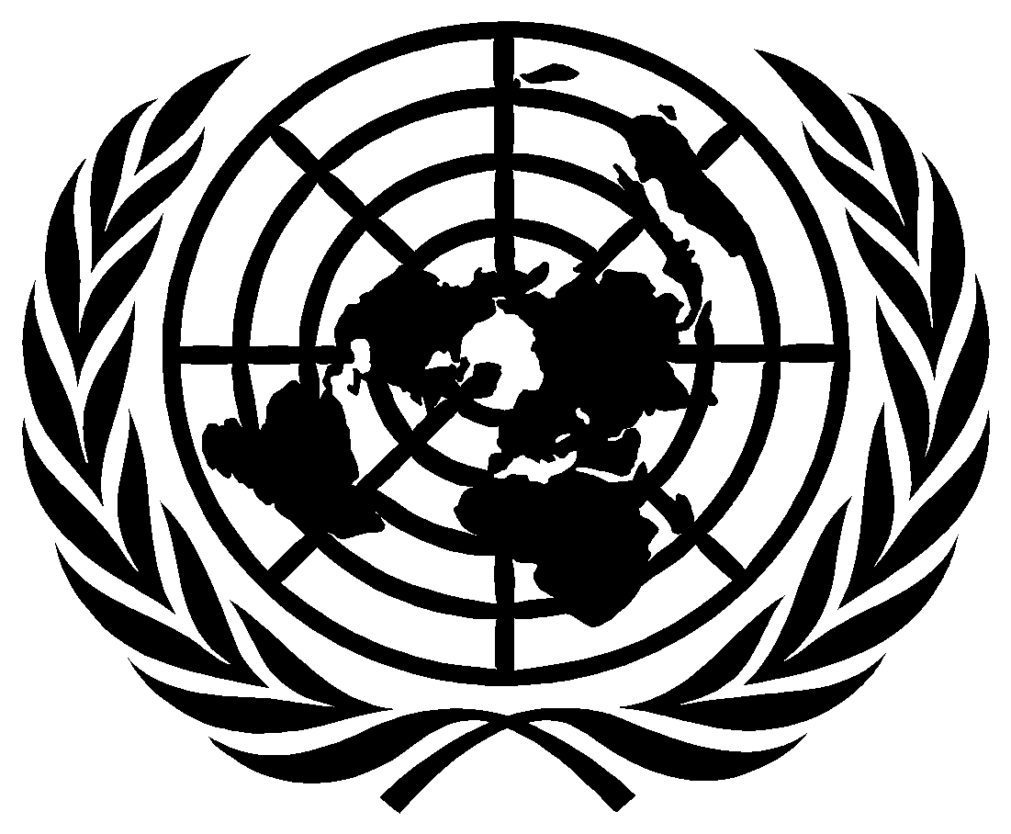 | General Assembly |  | Distr.: Limited  Original: English
Human Rights Council
Forty-eight session
13 September-7 October 2021
Agenda item 5
Human rights bodies and mechanisms

42/… Cooperation with the United Nations, its representatives and mechanisms in the field of human rights
The Human Rights Council,
Guided by the purposes and principles of the Charter of the United Nations,
Recalling General Assembly resolution 60/251 of 15 March 2006 and Human Rights Council resolutions 5/1, on institution-building of the Council, and 5/2, on the Code of Conduct for Special Procedures Mandate Holders of the Human Rights Council, of 18 June 2007,
Recalling also all previous General Assembly and Human Rights Council resolutions and decisions on this topic,
Reiterating that the promotion and protection of human rights should be based on the principles of cooperation and genuine dialogue, and be aimed at strengthening the capacity of Member States to comply with their human rights obligations for the benefit of all people,

Taking note with appreciation of all reports of the Secretary-General on cooperation with the United Nations, its representatives and mechanisms in the field of human rights, and noting with concern that the number of reported acts of intimidation and reprisals by States and non-States actors remains high, and the trends presented in the most recent report, including, inter alia, that acts of intimidation or reprisal online and offline can be more than isolated incidents, and can signal patterns; the growing self-censorship of victims and civil society actors who decide not to engage with the United Nations, both in the field and at Headquarters, out of fear for their safety or in contexts where human rights work is criminalized or publicly vilified; the use of national security arguments and counter-terrorism strategies by States as justification for blocking access to or punishment for engaging with the United Nations; that the most commonly reported incidents concern human rights defenders, activists and journalists; and that individuals in vulnerable situations or belonging to marginalized groups continue to be exposed to specific barriers, threats and violence in their engagement with the United Nations,
Noting that analysis of the United Nations data on alleged cases of intimidation and reprisals hold significant insights that can inform and improve policies and practices on intimidation and reprisals.
Welcoming the positive developments and good practices identified in the most recent report of the Secretary-General, in particular in relation to the development of legislative frameworks that ensure the right to access, communicate and cooperate with regional and international bodies or guaranteeing recourse to international forums; efforts to ensure accountability and offer remedy for incidents; the development of procedures or guidelines to prevent and address acts of intimidation and reprisal by the United Nations bodies and mechanisms in the field of human rights;, support for individuals at risk; and welcoming also the pledges by States to reject acts of intimidation or reprisal and support safe and unhindered access to the United Nations.
Welcoming also the different roles of the Secretary-General, the United Nations High Commissioner for Human Rights, the Assistant Secretary-General for Human Rights and the President of the Human Rights Council in supporting cooperation with the United Nations, its representatives and mechanisms in the field of human rights, and in that context addressing, as appropriate, including in a public manner, acts of intimidation or reprisal against individuals and groups who seek to cooperate, cooperate or have cooperated with the United Nations in this regard,
Welcoming the increased commitment and support by members of the Human Rights Council, Security Council and the General Assembly as well as ongoing initiatives within the United Nations system, including by field presences, to develop good practices, improve prevention, including in the digital sphere, and ensure better documentation, reporting and protection practices.
Welcoming further the work done by the United Nations, including the Office of the United Nations High Commissioner for Human Rights, in examining, verifying and corroborating allegations of acts of intimidation or reprisal, and encouraging it to continue its work in this regard, including in a gender-responsive manner, and with a particular focus on individuals in vulnerable situations or belonging to marginalized groups, while underlining the primary importance of continuous constructive dialogue and cooperation with and by the State concerned in order to strengthen the State’s capacity to comply with its human rights obligations,
Welcoming the work done by the special procedures, and in particular the Coordination Committee of Special Procedures, as well as the efforts by treaty bodies, to prevent and address acts of intimidation or reprisal,
Welcoming the role that regional mechanisms and national human rights institutions can playin preventing and addressing cases of intimidation or reprisal,
as part of supporting the cooperation between States and the United Nations in the promotion of human rights, including by contributing to follow-up actions, as appropriate, and to recommendations made by international human rights mechanisms, and noting with concern that national human rights institutions and their members and staff can themselves increasingly be victims of acts of intimidation or reprisal.
Reiterating that all States Members of the United Nations, and in particular the Members of the Human Rights Council, should fully cooperate with the Council and its mechanisms, and affirming that failure to take steps to prevent, investigate and ensure accountability for acts of intimidation or reprisal may be inconsistent with this commitment,
Expressing serious concern at the continued reports of acts of intimidation or reprisal against individuals and groups who seek to cooperate, cooperate or have cooperated with the United Nations, its representatives and mechanisms in the field of human rights, both online and offline, and at the seriousness of reported reprisals, including violations of the right of the victim to life, liberty and security of person, and violations of obligations under international law prohibiting torture and other cruel, inhuman or degrading treatment or punishment,
Stressing that acts of intimidation or reprisal carried out or tolerated by the State undermine and often violate human rights, and underscoring that States should investigate any alleged act of intimidation or reprisal, ensure accountability and effective remedies and take steps to prevent further acts of intimidation or reprisal,
Also recognizing that the pandemic has exacerbated and accelerated existing challenges, both online and offline, for civil society space, including human rights defenders and other individuals and groups engaging with the UN in the field of human rights, including inter alia: lack of diversity of participation; attacks, reprisals and acts of intimidation, including smear campaigns and use of hate speech; shortcomings in access and accreditation processes; the use of legal and administrative measures to restrict civil society activity; restrictions on access to resources; restrictions on access to lawyers; restrictions on the rights to freedom of peaceful assembly and association, and freedom of expression; and increased impact of the digital divide.
Noting that cooperation with the United Nations has been significantly altered by COVID-19, including the shift to hybrid and online formats for interaction with the UN and recognizing that the legitimate need for emergency public health measures should not be used to hinder the access of individuals and civil society organizations to the United Nations, its representatives and mechanisms in the field of human rights.
Recalling in this regard the call by the Secretary General (A/HRC/45/36) that the UN’s work, carried out increasingly online as a result of Covid-19, has to ensure that participation remains meaningful, effective, easily accessible and free from intimidation or reprisals of any sort, including online smear campaigns.
1. Reaffirms the right of everyone, individually and in association with others, to unhindered access to and communication with international bodies, in particular the United Nations, its representatives and mechanisms in the field of human rights, including the Human Rights Council, its special procedures, the universal periodic review mechanism and the treaty bodies, as well as regional human rights mechanisms, both online and offline, bearing in mind that this is indispensable to enable the United Nations and its mechanisms to fulfil their mandates;
2. Condemns all acts of intimidation or reprisal, both online and offline, by State and non-State actors against individuals and groups who seek to cooperate, cooperate or have cooperated with the United Nations, its representatives and mechanisms in the field of human rights;
3. Welcomes the efforts made by States to investigate allegations of acts of intimidation or reprisal and to bring perpetrators to justice, and encourages States to continue such efforts;
4. Urges all States to prevent and refrain from all acts of intimidation or reprisal, both online and offline, against those who:
(a) Seek to cooperate, cooperate or have cooperated with the United Nations, its representatives and mechanisms in the field of human rights, or who have provided testimony or information to them;
(b) Avail or have availed themselves of procedures established under the auspices of the United Nations for the protection of human rights and fundamental freedoms, and all those who have provided legal or other assistance to them for this purpose;
(c) Submit or have submitted communications under procedures established by human rights instruments, and all those who have provided legal or other assistance to them for this purpose;
(d) Are relatives of victims of human rights violations or of those who have provided legal or other assistance to victims;
5. Urges States to take all appropriate measures to prevent the occurrence of acts of intimidation or reprisal, whether online or offline, including, where necessary, by adopting and implementing specific legislation and policies to promote a safe and enabling environment for engagement with the United Nations on human rights and to effectively protect those who seek to cooperate, cooperate or have cooperated with the United Nations, its representatives and mechanisms in the field of human rights from any act of intimidation or reprisal;
. ;
6. Calls upon States to combat impunity by conducting prompt, impartial and independent investigations and ensuring accountability for all acts of intimidation or reprisal by State and non-State actors against any individual or group who seeks to cooperate, cooperates or has cooperated with the United Nations, its representatives and mechanisms in the field of human rights, , both online and offline, and by condemning publicly all such acts, underlining that these can never be justified, and to provide access to effective remedies for victims in accordance with their international human rights obligations and commitments, and to prevent any recurrence
7. Calls upon States to ensure that COVID-19 related necessary emergency measures are not used to hinder the access of individuals and groups to international bodies, both online and offline, in particular the United Nations, its representatives and mechanisms in the field of human rights.
8. Encourages States to provide information, as appropriate, to the Human Rights Council on all measures taken by them to prevent and address acts of intimidation or reprisal against those who seek to cooperate, cooperate or have cooperated with the United Nations, its representatives and mechanisms in the field of human rights, including on cases mentioned in the reports of the Secretary-General;
9. Stresses that information provided by all stakeholders, including civil society, to the United Nations and its representatives and mechanisms in the field of human rights should be credible and reliable, and must be thoroughly checked and corroborated;
10. Invites the Secretary-General to continue to provide the Office of the United Nations High Commissioner for Human Rights with adequate resources to prevent and address allegations of acts of intimidation or reprisal in the most effective and gender-responsive manner, including by ensuring a safe and enabling environment, both online and offline, for all those who seek to cooperate with the United Nations on human rights, including the Human Rights Council, the special procedures, the treaty bodies and other human rights mechanisms or United Nations forums;
11. Notes with appreciation the focus on civil society in the report of the High Commissioner on the Impact of the COVID-19 pandemic on the enjoyment of human rights around the world, including good practices and areas of concern, as a way to “Build Back Better”.
12. Encourages the Assistant Secretary-General for Human Rights to strengthen efforts to develop and implement at the United Nations level a more comprehensive system for preventing and addressing allegations of acts of intimidation or reprisal, including by information gathering and data analysis, as well as improving and coordinating the response by all United Nations actors, and in this regard calls upon all States and relevant stakeholders to contribute to these efforts;
13. Welcomes the steps taken by the President of the Human Rights Council and encourages the President to continue, in consultation with the States concerned, to use his or her good offices to address as appropriate allegations of acts of intimidation or reprisal against those who seek to cooperate, cooperate or have cooperated with the Council, and to provide information on cases brought to his or her attention at each session of the Council;
14. Encourages the United Nations human rights mechanisms to continue to include in their reports to the Human Rights Council and to the General Assembly respectively a regularly updated reference to credible allegations of acts of intimidation or reprisal against those who seek to cooperate, cooperate or have cooperated with the United Nations, its representatives and mechanisms in the field of human rights, while providing an appropriate opportunity to the State concerned to respond to the allegations transmitted to them, and to reflect the State’s response in their reports;
15. Invites the Secretary-General to submit the report he or she presents annually to the Human Rights Council on cooperation with the United Nations, its representatives and mechanisms in the field of human rights also to the General Assembly as from its seventy-seventh session. .

A/HRC/42/30.

